Puzzle game reskin guidelines

**Change App Name**

1. Go to project and open it in xcode
2. Add new app name in display name field
3. Please refer to below screenshot

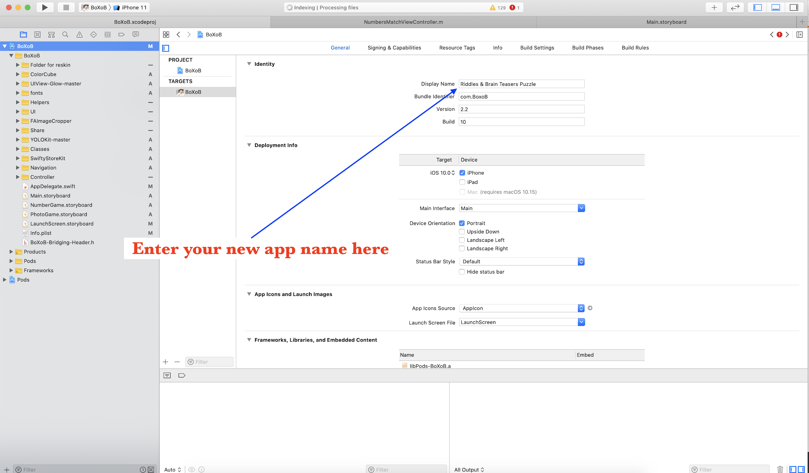

**Change admob id**

1. Create your new admob interstitial ad unit id
2. To create new app is please follow this link <https://support.google.com/admob/answer/7311435?hl=en&ref_topic=7382891>
3. Copy your admob unit id and paste it in unitId variable inside cosntant.swift class
4. Please refer to screenshot below

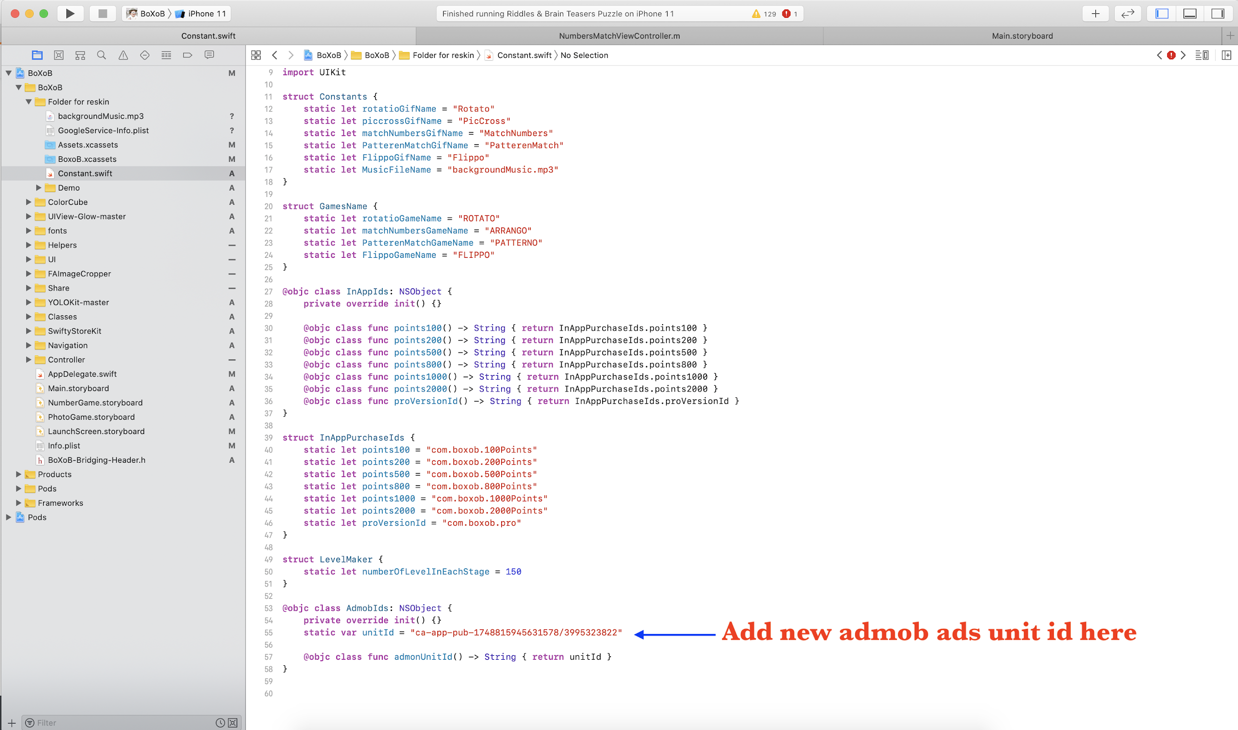

Copy your admob id and past it inside “GADApplicationIdentifier” key in info.plist file

Please follow screenshot below for more information

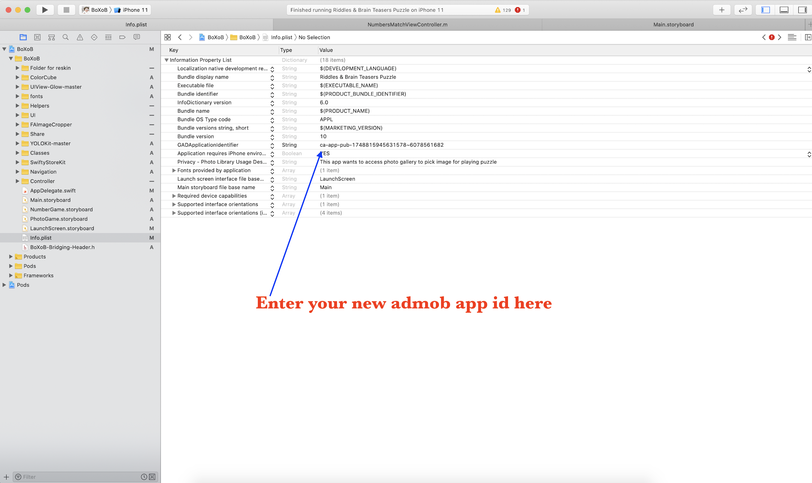

**Change app graphics**

1. Go to “Assets.xcassets” folder and replace all graphics icons with your created icons including app icon as shown in below screenshot

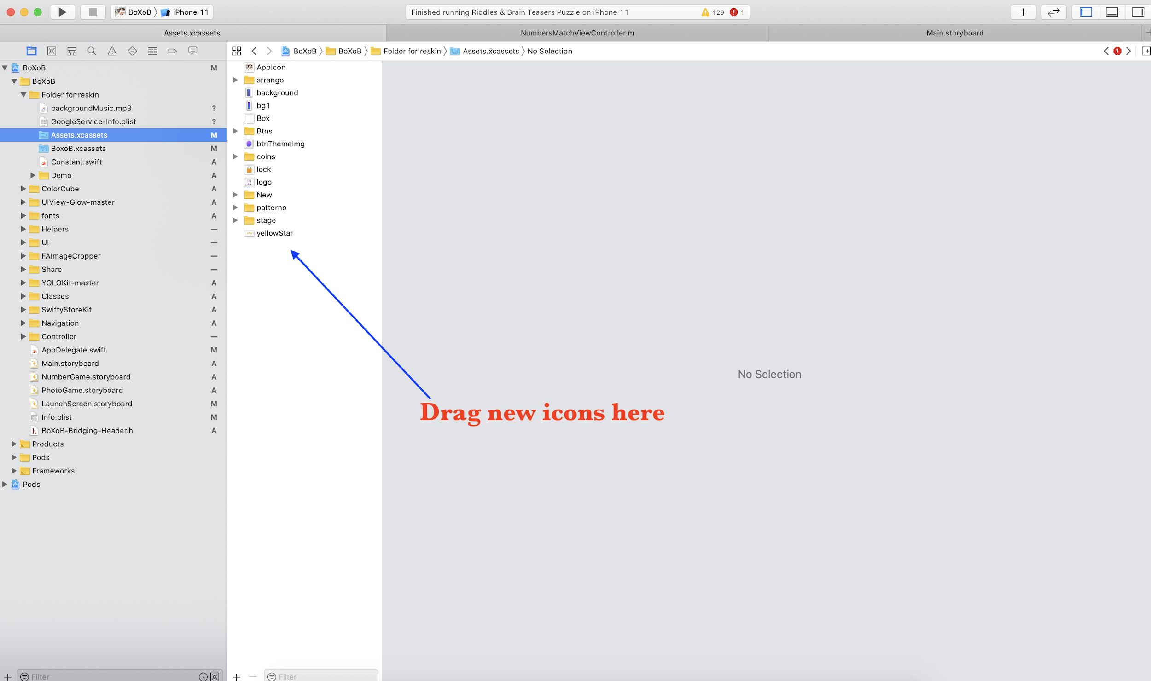

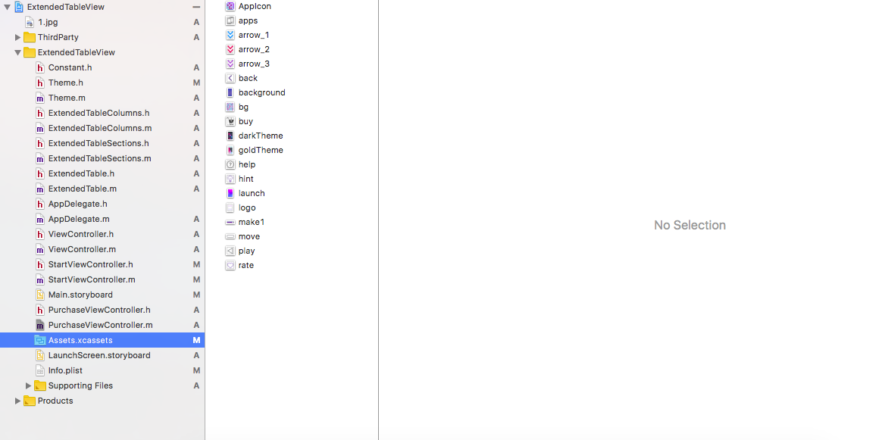

**Replace puzzle images**

Please note here. We are using 150 puzzle images in this app. To reduce the app binary size we are storing some of the images on firebase storage. Locally we are saving only 25 images and rest of the images are saved on firebase.

**How to change local puzzle images**

1. Create new your new puzzle images of square size for best quality result.
2. Named those images from 1 to 25, because we are accessing these images by their names. Make sure the names of images should be exactly same as already given i.e 1 to 25
3. Open the “BoxoB.xcassets” folder and drag the new puzzle images here

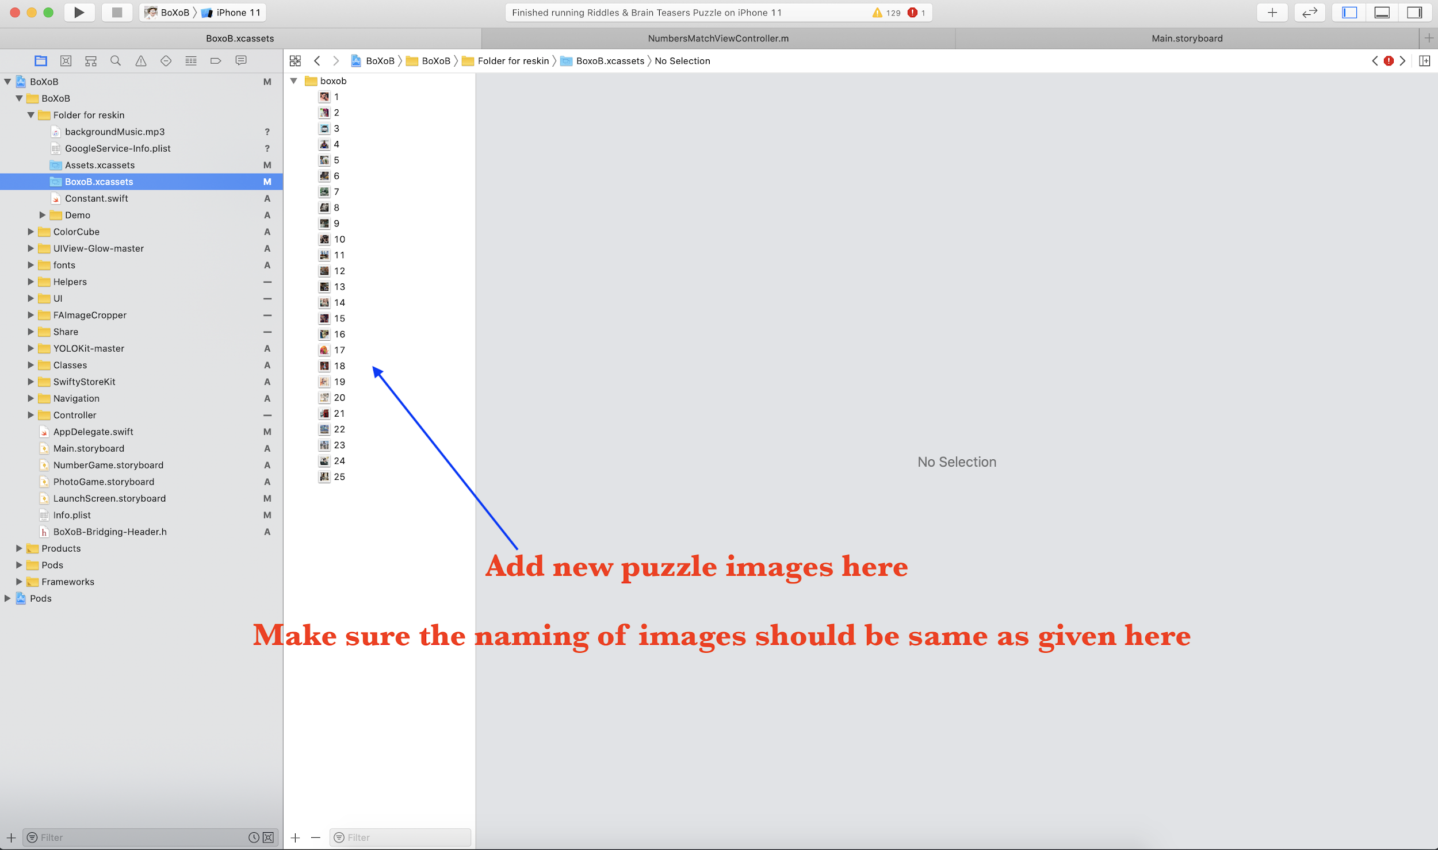

**How to change puzzle images added on firebase**

1. Create account of firebase
2. Add a new app on firebase
3. Please follow this link to create new app on firebase “<https://firebase.google.com/docs/ios/setup>”
4. Now prepare you rest of the images and name it from 26 to 150
5. Select the storage section of firebase app as shown in screenshot below and upload all new puzzle images here

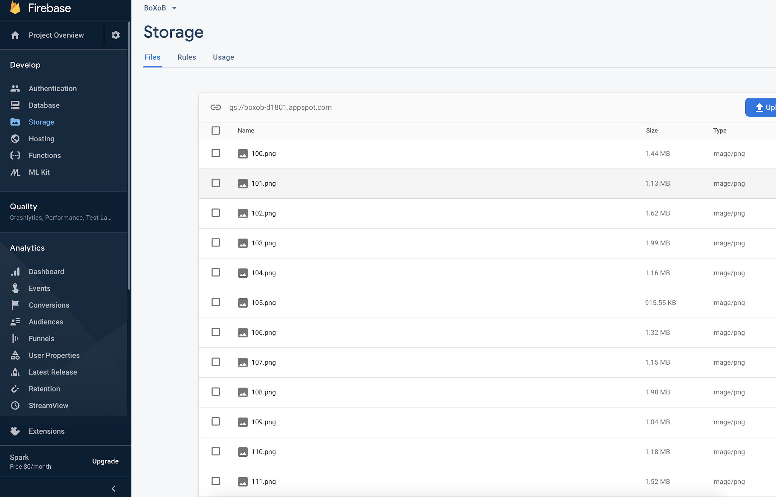

**Replace in app purchase Id’s**

Go to itunes connect and create your own in app products as give in below link

1. <https://www.raywenderlich.com/122144/in-app-purchase-tutorial>
2. <https://docs.microsoft.com/en-us/xamarin/ios/platform/in-app-purchasing/in-app-purchase-basics-and-configuration>

Go through in app purchase sections in below links

After adding in app purchase products on itune open constant.file file as shown in below screenshot

Replace in app purchase products id’s with your own in app purchase products id’s

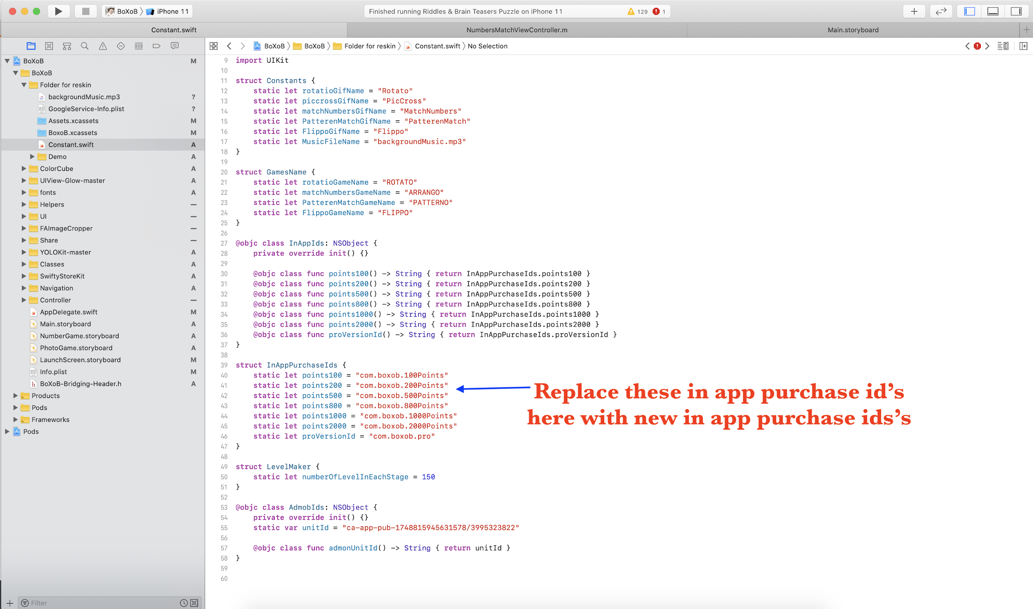

**Change background music file**

1. Create new music file
2. Remove the old file and drag it into xcode as shown in below screen shot

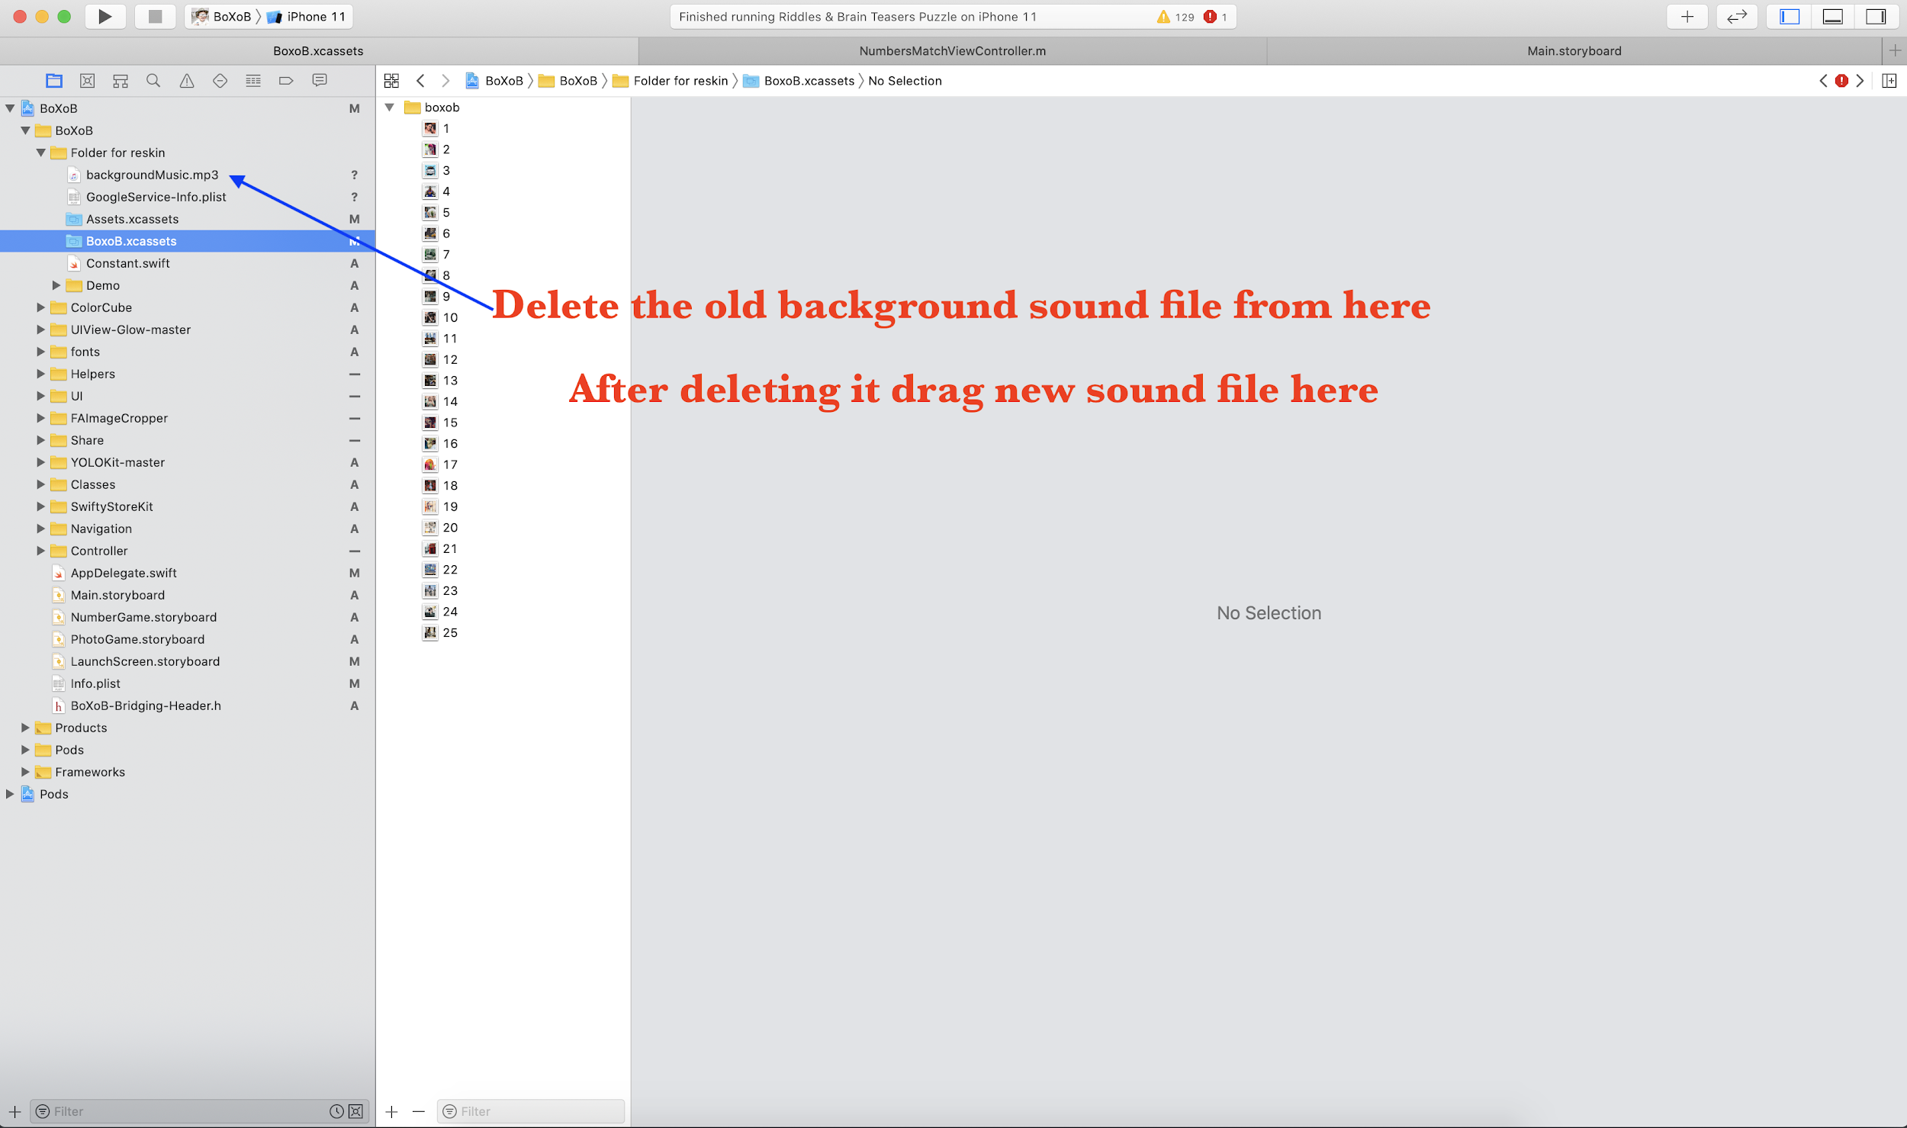

**Change background music file name**

After dragging the new file if the file name same as previous file name then nothing needs to be done more but if your new file name is different then you have to give new file name to MusicFileName variable in constant.swift file. Please refer to below screenshot

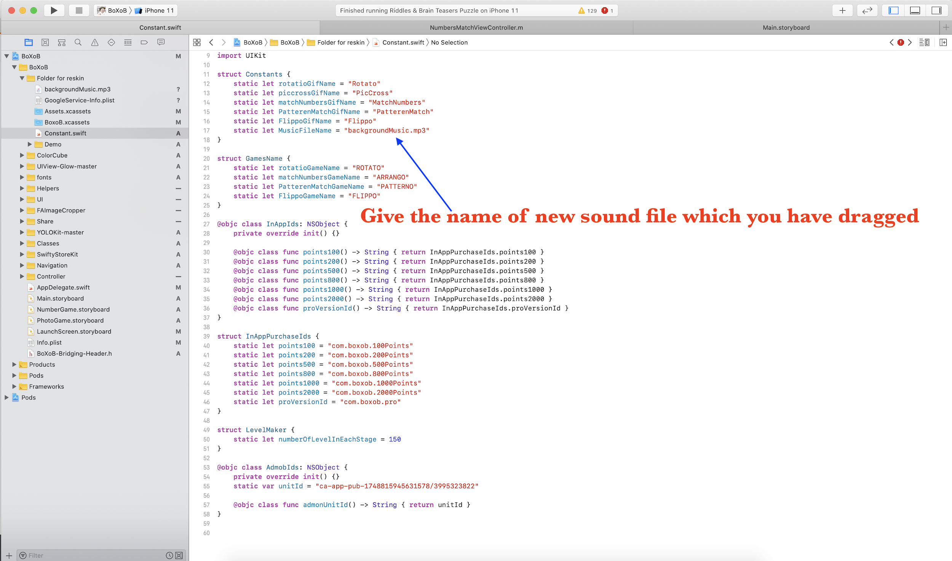

Now you have setup all the things here and you are ready to archive and submit the binary for review

Good Luck

Thanks for buying